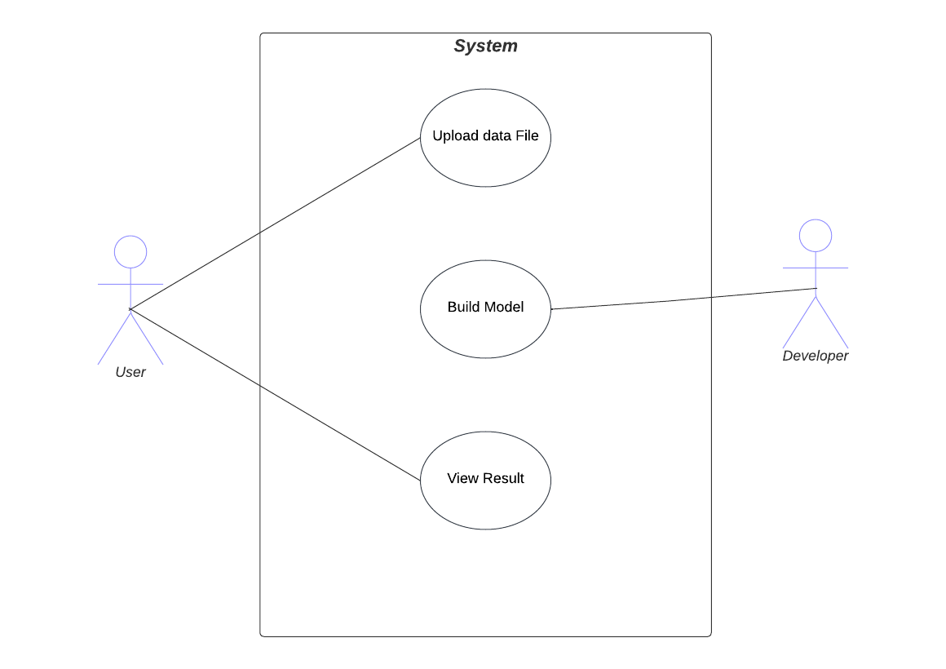

**Fig 1: Use Case Diagram**

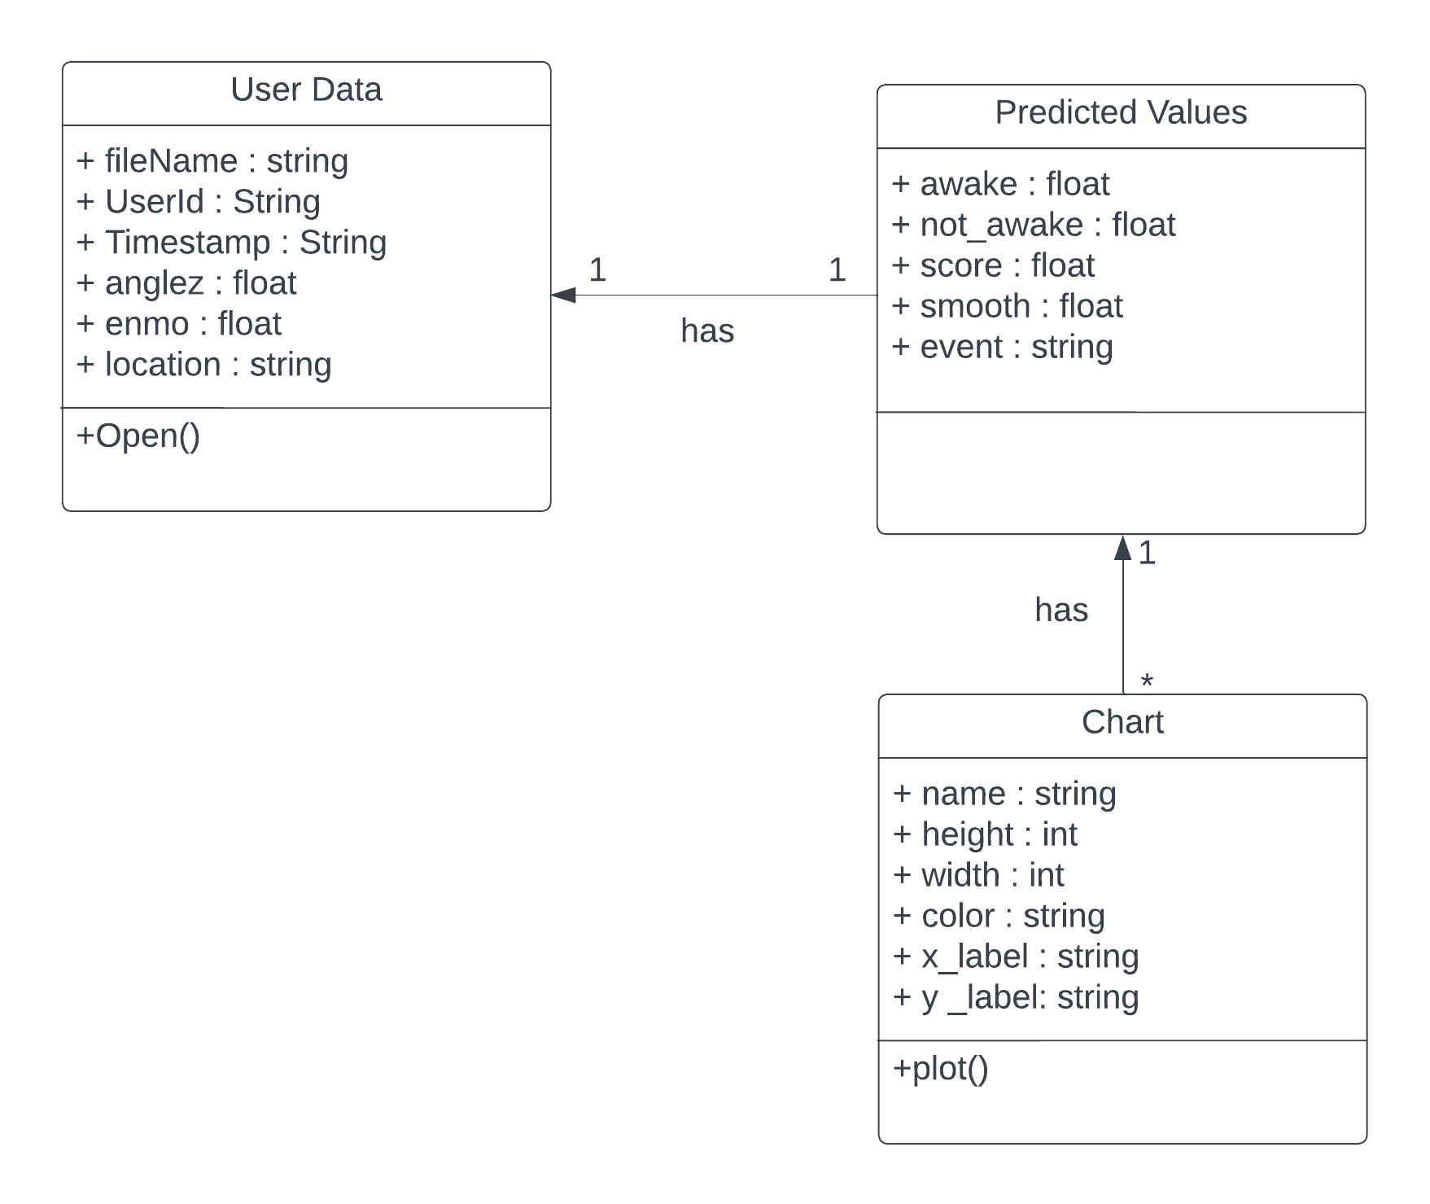

**Fig 2: Class Diagram**

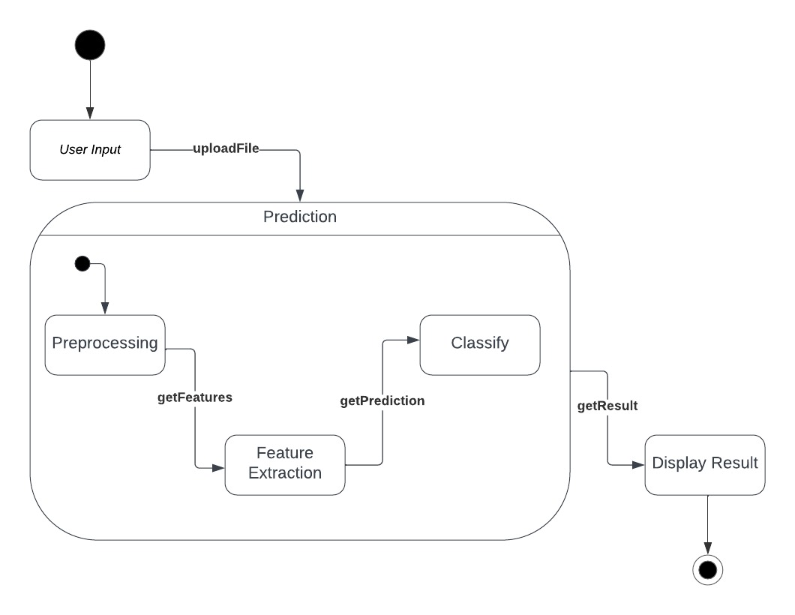

**Fig 3: State Diagram**

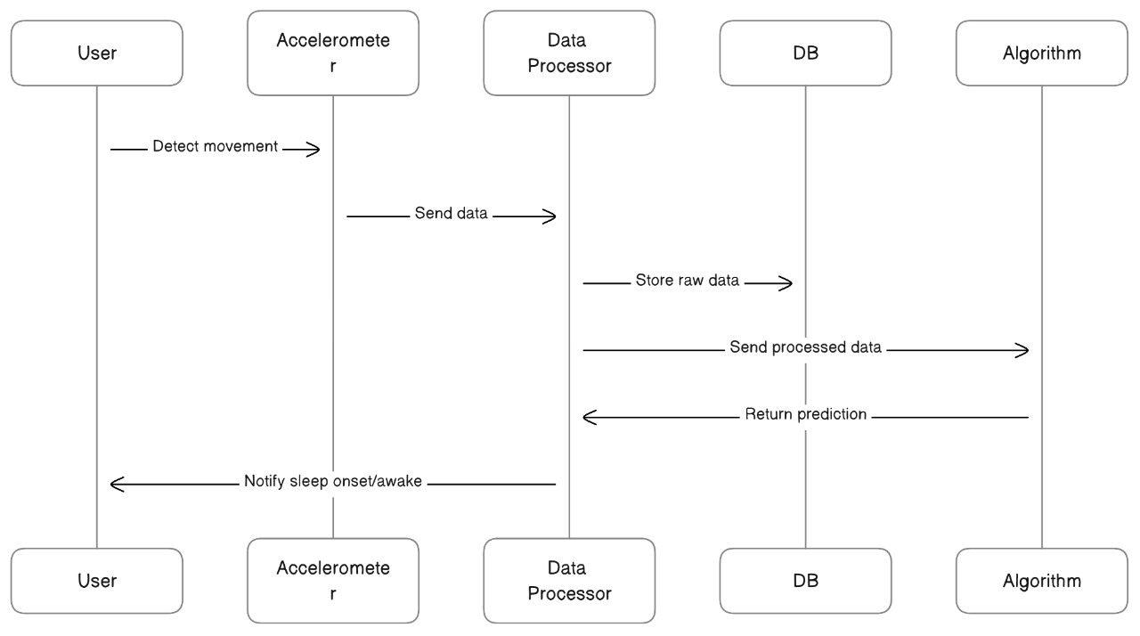

**Fig 4: Sequence Diagram**

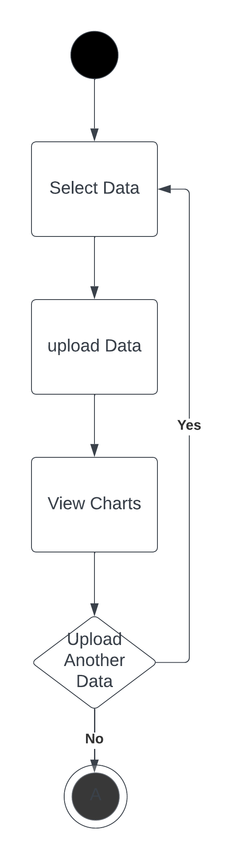

**Fig 5: Activity Diagram**

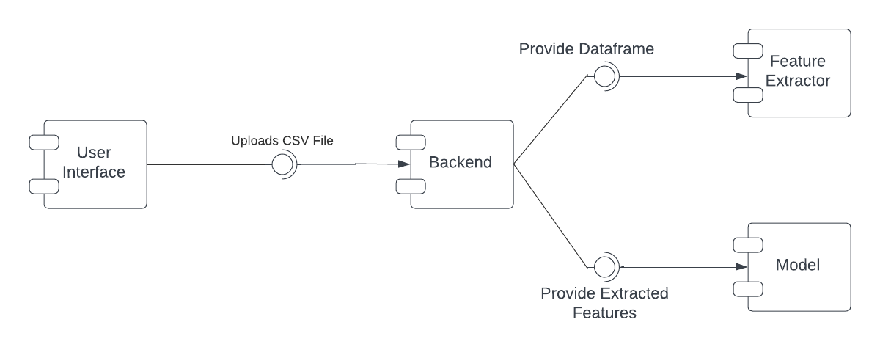

**Fig 6: Component Diagram**

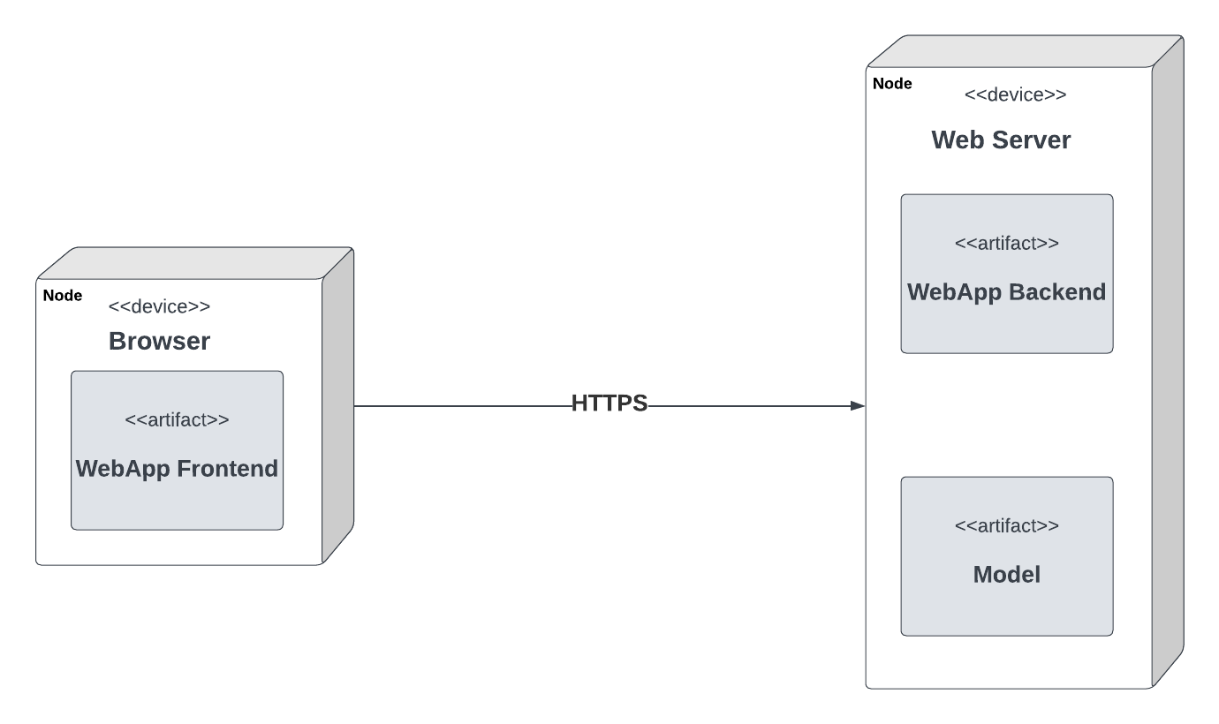

**Fig 7: Deployment Diagram**